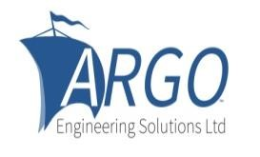
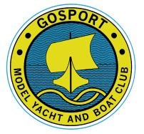
NOTICE OF RACE
MINI-40 OPEN MEETING

Saturday 11th and Sunday 12th April 2026
Sponsored by Argo Engineering Solutions Fast, Fun, Fantastic!
at
Gosport Model Yacht and Boat Club,
Walpole Lake, Gosport, Hants PO12 1FA
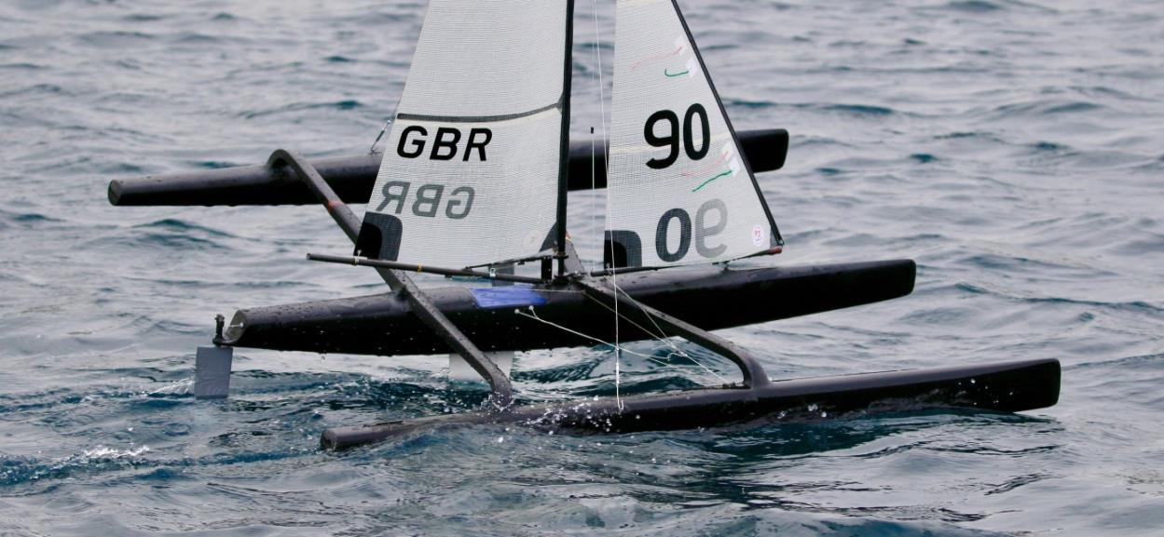

1. Event Schedule Friday 10th April 2026 13.00 – 16.00 Registration and scrutiny Saturday 11th April 2026
8.30 to 9.00 Registration and scrutiny
09.15 Welcome and Briefing
Racing will commence not less than 15 minutes after Briefing
16.30 No race will start after this time and any heat in progress at 17.00 hrs will be abandoned.

Sunday 12th April 2026
09.15 Briefing
Racing will commence not less than 15 minutes after Briefing
15.00 No race will be start after this time and any race in progress at 15.30 will be abandoned.

2. Entry and Eligibility
Entry is open to all members of MYA affiliated Clubs, guests of the host club and to members of foreign clubs affiliated to a Delegated National Member of IRSA. Other entrants must be able to show liability insurance cover equivalent to five million pounds sterling.
E-mail or post your completed entry form to jacquecook48@icloud.com or 14 St Helens Road Hayling Island Hants PO11 0BT
The final closing date for receipt of entries is Friday April 3rd 2026

3. Entry Fees
Entry fees are £20.00 for the event payable in advance with entry preferably, as detailed on the entry form by bank transfer or by arrangement with the Event Secretary as detailed in section 16. Please note that once an entry has been accepted, except in extreme circumstances, the fee must be paid even if the competitor does not attend. Late entries
GMYBC MH OPEN NOR 10 February 2026

may be accepted at the discretion of the organisers, but they will attract an administration fee. Should the event be cancelled, entry fees will be returned.

4. Competitors with Disability
Competitors that require any form of help or special arrangements should, prior to entry, get in touch with the contact given in section 16 to check if the club is able to help with the provision of any such special requirements. The onus is on the competitor to establish whether the available facilities are adequate before deciding to enter the event.

5. Emergency Contact Form
In case of accidents, all competitors MUST complete the emergency contact details on the entry form. The forms will be destroyed after the event.
6. Use of Images
Competitors are asked to complete the section on use of their images on the entry form.

7. Disclaimer of liability
Competitors participate in the regatta entirely at their own risk. The organizing authority will not accept any liability for material damage or personal injury, or death sustained in conjunction with or prior to, during, or after the event. At all times the responsibility for the safety of their boat and themselves plus the decision to participate or to continue must rest with the competitor.
GMYBC lakes are protected by Natural England who govern what we can do to the lakes to prevent weed from interfering with the sailing. Whilst every effort will be made to ensure the lake is in the best condition, neither GMYBC, nor any of the organising committee or club members, can be held responsible if the event is disrupted or cancelled due to any problems with the lakes or weed.

8. Sailing Instructions
This event will be run under the current version of the Racing Rules of Sailing modified by section E and the MYA SSI’s. The scoring system will be the HMS, latest version supplied by the MYA. Observers may be drawn from the competitors. Individuals required to sit on protest committees will be drawn from competitors should this be needed.
9. Entry List, Sail Numbers and Frequency Allocation.
An entry list, sail numbers and frequencies will be published on the GMYBC Website www.gosportmybc.club.uk in the section entitled ‘Events and Races’ click on ‘Multihull’.

10. Scrutiny
Scrutiny will take place on Friday 10th of April from 13.00 until 16.00 and Saturday 11th of April from 08.30 until 09.00. All skippers must present their boats for scrutiny prior to racing.

11. Accommodation
There are a number of hotels, bed and breakfasts, self-catering and camping accommodation available locally. The nearest is probably the Travelodge which is only a few minutes from the club.

12. Parking
There is a pay council car park adjacent to the club house.. If you are staying in the
Travelodge, parking is free in their car park. On Sunday, parking is free on the road.

13. Refreshments
Hot and cold refreshments will be available throughout the event from the Lakeside Café and Bar above the clubhouse. The galley in the clubhouse will have drinks, cake and biscuits available.

14. Boat Storage
Boats will be able to be stored unrigged in the club boat store until the end of the event on Sunday 12th April.

15. Evening Meals
On Friday 10th there will be a free fish and chips supper courtesy of our sponsor at the club. On Saturday an evening meal will be arranged, if competitors and other visitors would like to attend. Please indicate interest on the entry form. Details of menu and cost will follow.

16. Contact
If you have any further queries please contact Jacque Cook telephone:07846502010, or e- mail jacquecook48@icloud.com or post to Jacque Cook, 14 St Helens Road, Hayling Island, Hants PO11 0BT England.

GMYBC MH OPEN NOR 10 February 2026

