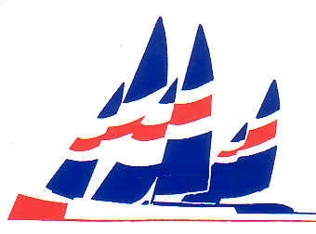
MYA VANE 36 NATIONAL CHAMPIONSHIP AT
GOSPORT MYBC 2nd, 3rd and 4th of May 2026
APPENDIX B MATE ENTRY FORM
A completed entry form is required from EACH individual racing, skippers and mates.
Name |  | MYA No |  | Dob if Aged under 18 on 1/1/22 or aged over 60 on 1/1/22
Address |  | Phone no
 |  | Mobile no
 |  | E-mail
Post code |  | Club
Emergency Contact Details
Emergency Contact Name: |  |  | Relationship:
Emergency Contact Home Number:
Emergency Contact Mobile Number:
Any Medical Conditions that event organisers should be advised? (allergies, Diabetes etc)

I am a trained first-aider/have medical experience and am willing to be called on in an emergency: yes / no

I give permission for photographs that include me to be published: yes / no

I will be sailing as mate my skipper is:

Evening meal on Saturday, details to follow. How many and who?
Completed forms may be returned via e-mail Jacquecook48@icloud.com or by post to Jacque Cook, 14 St Helens Road, Hayling Island, Hants PO11 0BT by Wednesday 22nd April

I have read the regulations for race entry and agree to abide by them.

Signature Date

